VEHICLE SPEED CONTROLLER USING ULTRASONIC SENSOR

Khuyen V.Vu

Information Technology

VAMK

Email: vankhuyenvu1904@gmail.com

*Abstract*—Safety is the problem Finland always puts first. Nowadays, we have so many transportations in operation, so the parking area always being crowded. Therefore, the customer will sometimes jostle each other out of the basement and maybe lead to unnecessary accidents. That is why I created a system that can solve that issue which can create order when taking the car and also keep the safest to customers.

# I. INTRODUCTION

According to these issues above, I would like to create a system that can have a safe distance between each car, by using an Ultrasonic sensor in order to control the traffic light to manage the speed of the vehicle, especially cars.

Ultrasonic sensors work by sending out a sound wave at a frequency above the range of human hearing. The transducer of the sensor acts as a microphone to receive and send the ultrasonic sound. Our ultrasonic sensors, like many others, use a single transducer to send a pulse and to receive the echo. The sensor determines the distance to a target by measuring time lapses between the sending and receiving of the ultrasonic pulse.

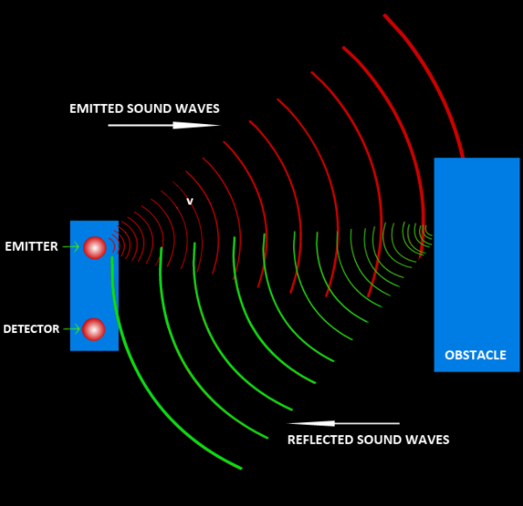

After the sensor received the waves, the Arduino will control the traffic light (RGB) to inform the suitable speed to customers. The traffic light works the same as the transport light. Normally, the light is red and the entrance is will be closed. When the car is in the station, the light will be yellow and the car has to go slowly. Then the car has to wait for the entrance to be opened and the light is green before can go through.

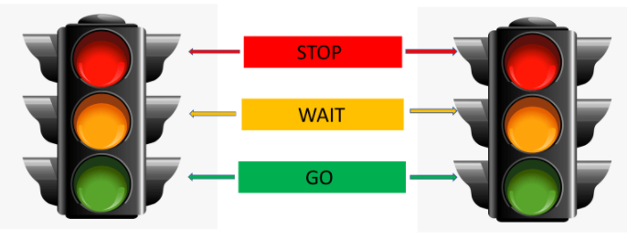

# II. BACKGROUND

Arduino is an open-source electronics platform based on easy-to-use hardware and software. Arduino boards are able to read inputs - light on a sensor, a finger on a button, or a Twitter message - and turn it into an output - activating a motor, turning on an LED, publishing something online

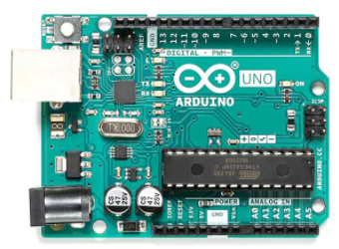

An ultrasonic sensor is an electronic device that measures the distance of a target object by emitting ultrasonic sound waves and converting the reflected sound into an electrical signal. Ultrasonic waves travel faster than the speed of audible sound

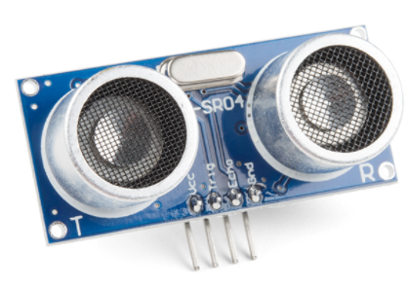

RGB LED means red, blue, and green LEDs. RGB LED products combine these three colors to produce over 16 million hues of light. Note that not all colors are possible. Some colors are “outside” the triangle formed by the RGB LEDs. Also, pigment colors such as brown or pink are difficult, or impossible, to achieve.

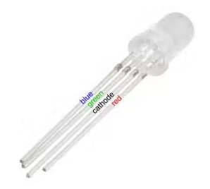

Servo is a kind of driver for position (angle) servo. It is suitable to control a system with constant angle change and can remain its status. In this experiment, we are going to use micro: bit to make a servo rotate circularly within a travel range.

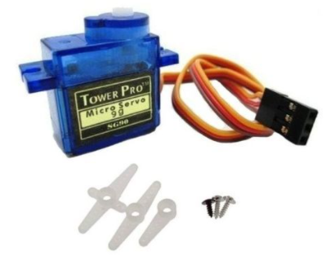

# III. MOTIVATING EXAMPLE

We can apply a lot of things in real life for this project. The main thing is how we can use the micro servo and signal of the sensor efficiently.

Toll tax station:

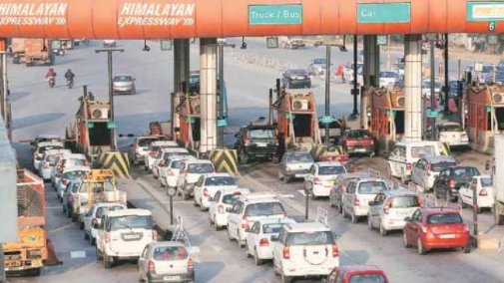

Auto trash bin:

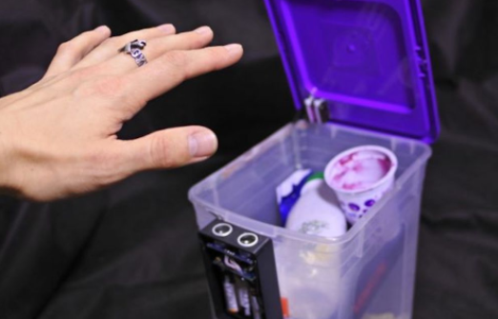

Automatic faucet:

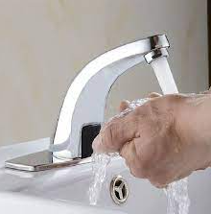

And so many things in real life we can use with Arduino and Ultrasonic sensors…

# III. METHOD – TOOL - CODE

In this project, we need to use:

## A. Arduino Uno:

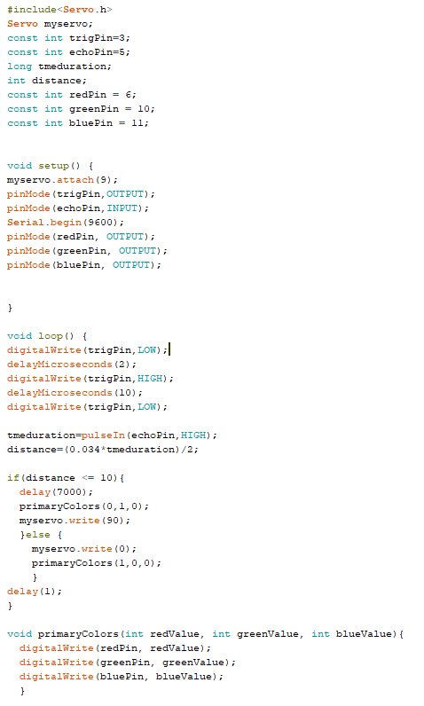

This is the code that controls the system. It has 4 parts:

The first part is used to call a declaration or defining, here we are assigning pin numbers to send/receive signals from modules and the pin to assign RGB led.

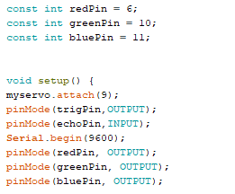

In the second part, we are giving output pin declaration in our case as we are using micro servo we are assigning pin number 9(D9) and giving the command as which are the Input pins and what are the output pins for the ultrasonic sensor and also set the pin mode for RGB led.

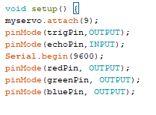

Third, we are setting up the servo horn lifting angle and the response time, if you want any changes in the angle of rotation or delay at which the servo should work you can modify myservo.write or delay values, if you have the requirement as In this project I recommend not to make any changes then add the color of RGB led according to the sensor

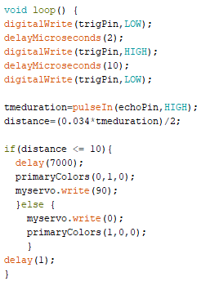

And the final part is using support to control the color of the RGB led.

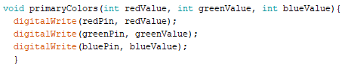

## B. Ultrasonic Sensor:

Ultrasonic sensors work by sending out a sound wave at a frequency above the range of human hearing. The transducer of the sensor acts as a microphone to receive and send the ultrasonic sound. Our ultrasonic sensors, like many others, use a single transducer to send a pulse and to receive the echo, following equation.

**Range = Time of Fight / (2 * Speed of Sound)**

## C. Micro Servo:

Micro servo is used as a switch to control the entrance which can open or close depending on the signal of the sensor and the RGB led.

## D. RGB LED:

By using only one LED then we have to know how RGB LED works. It is using the PWN in Arduino to assign the color of LED.

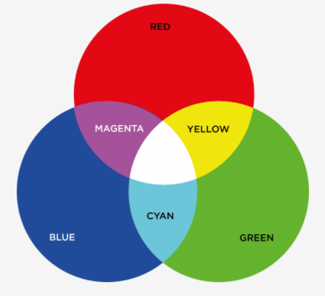

## E. Flowchart:

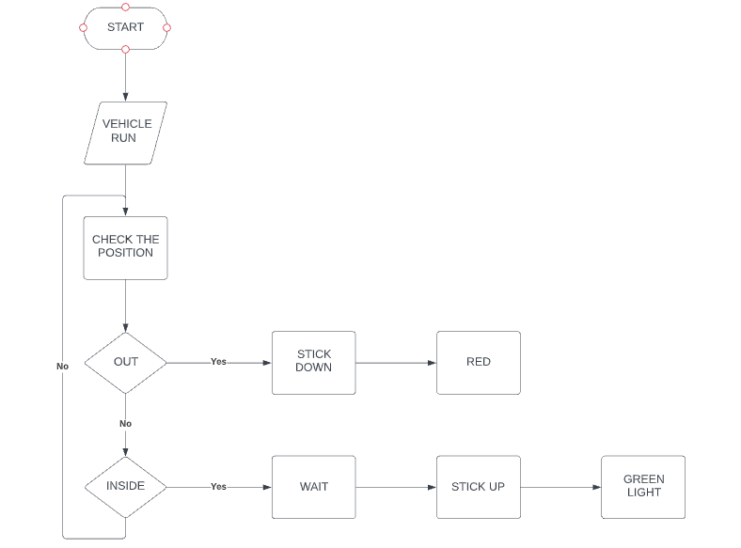

## E. Schematic:

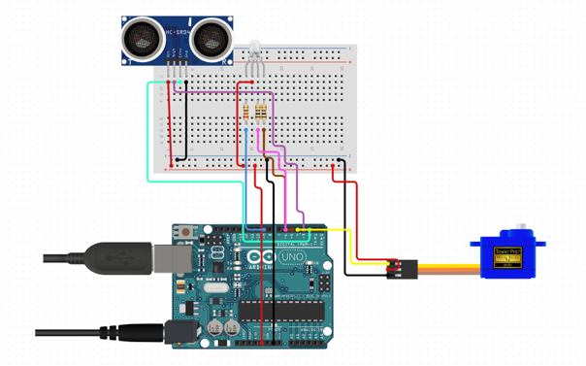

# IV. RESULT

Note that I changed the Pins:

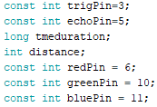

This is the whole system after accomplishing.

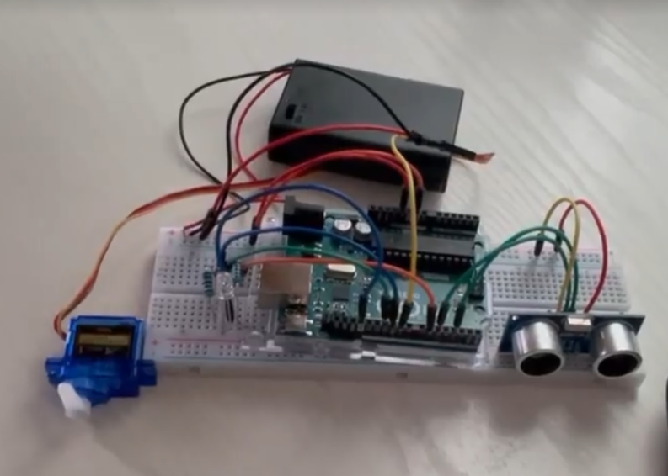

When we turn it on, the sensor will work immediately to check whether the obstacle appears, then the light and the stick will change to the color suitable for the system.

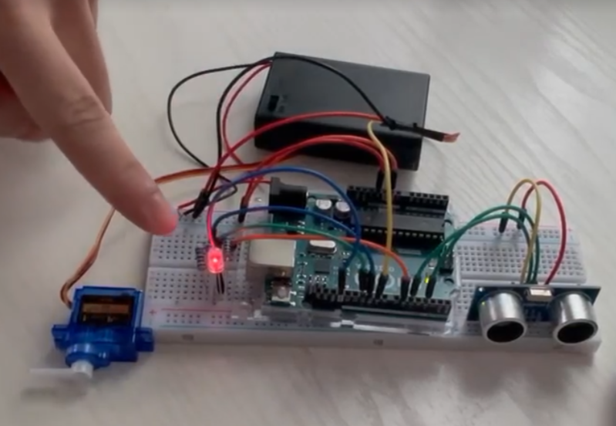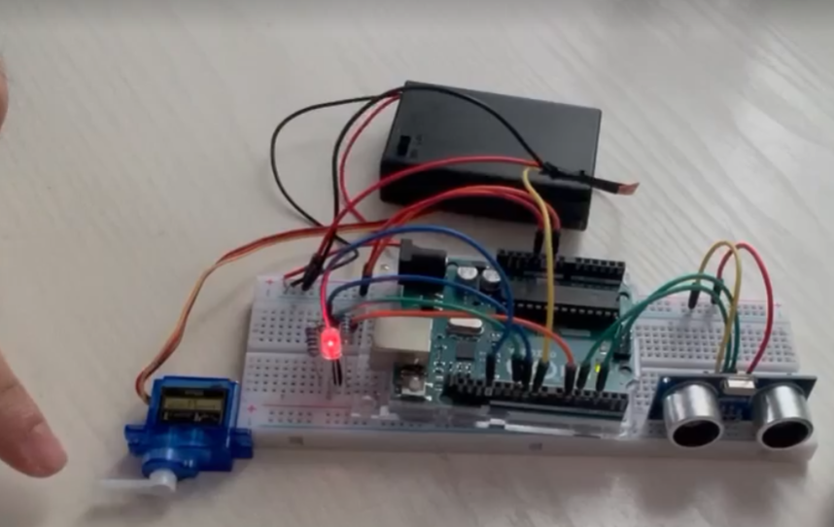

When the obstacle comes, the entrance will be closed, and wait a little bit to be safe. After a while, the stick and the light will open automatically when the vehicle can go through.

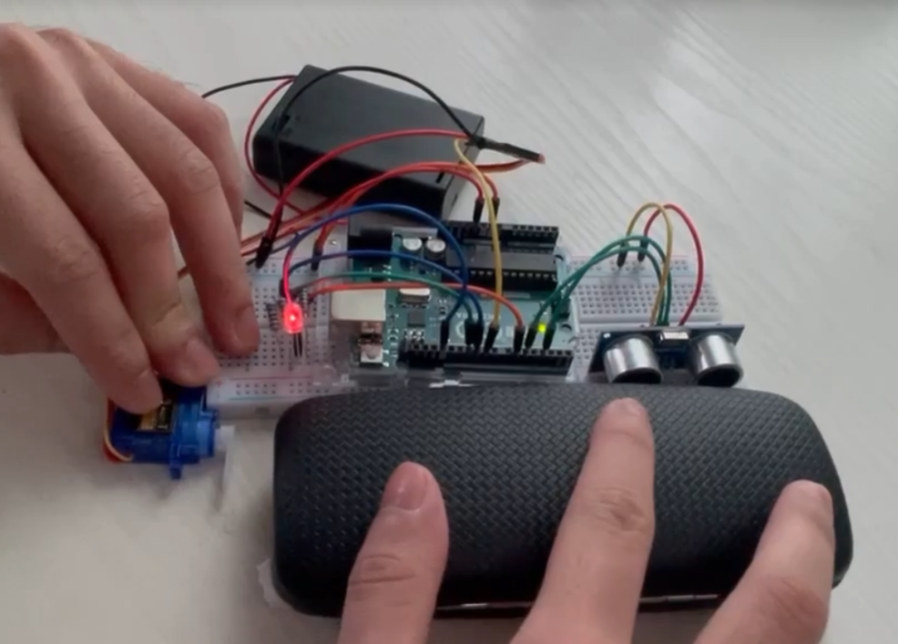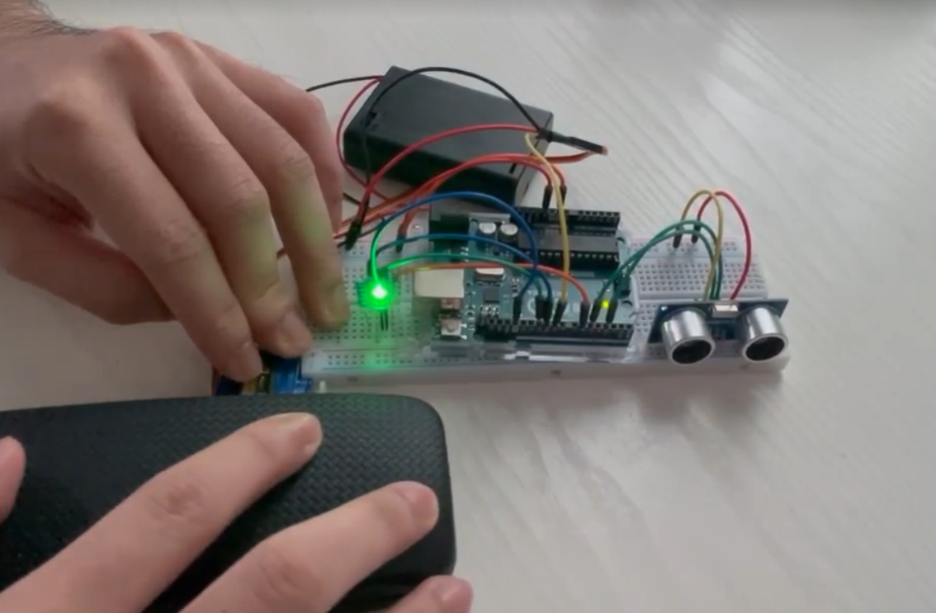

After all, the system turns back to the beginning state.

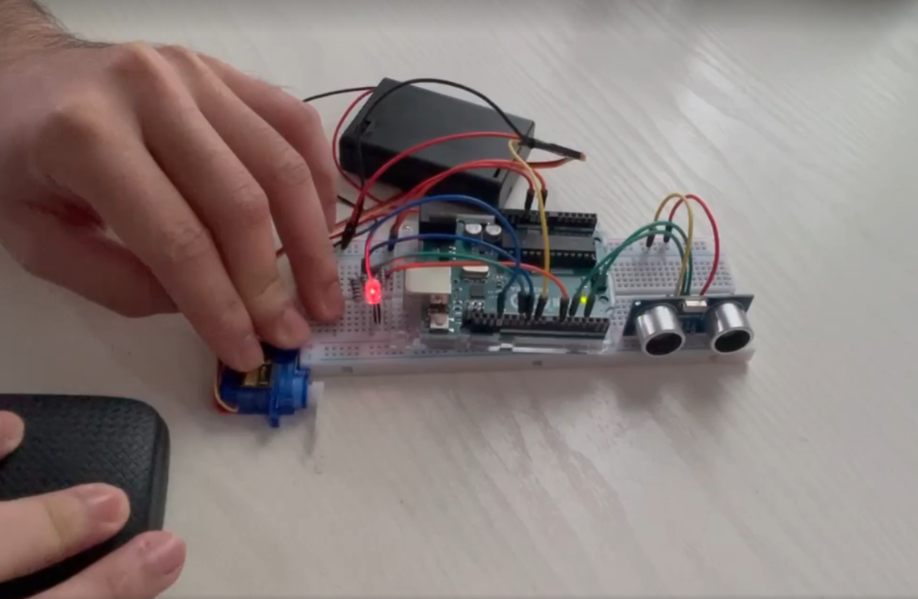

This is a small project so I do not have good facilities to make it better. Generally, we can see all of the visual system.

# V. LIMITATION AND DISCUSSION

## A. Limitation:

Although the system is quite safe, we have to change our time to have it. In fact, the most disadvantage is creating heavy traffic because people have to wait for their turn to go through. One more thing that because we are using the sensor to work, we have to check the sensor periodically, so the system can work fluently without worry.

## B. Discussion:

In real life, you can see a lot of things have this system inside. I think if the system needs to check the position of something or has an automatic entrance, will use this sensor. Sure that in the future, the expert will improve it to be a new version. For example, we can change the system of traffic lights by using this sensor at night, the sensor will check whether people are there then the light will change by the order of the sensor. And so many things will be enhanced onward.

# REFERENCES

Engr Fahad. (2021). *Toll Tax System using Arduino: Ultrasonic Sensor with Servo Motor.* Technical Report, UAE.

https://www.electroniclinic.com/toll-tax-system-using-arduino-ultrasonic-sensor-with-servo-motor/